**1.**

Enter “Start Menu->Programs->Qt for Symbian by Nokia v4.7.0-beta1->Qt for Symbian Command Prompt”, open it, it will pop-up DOS dialog as below:

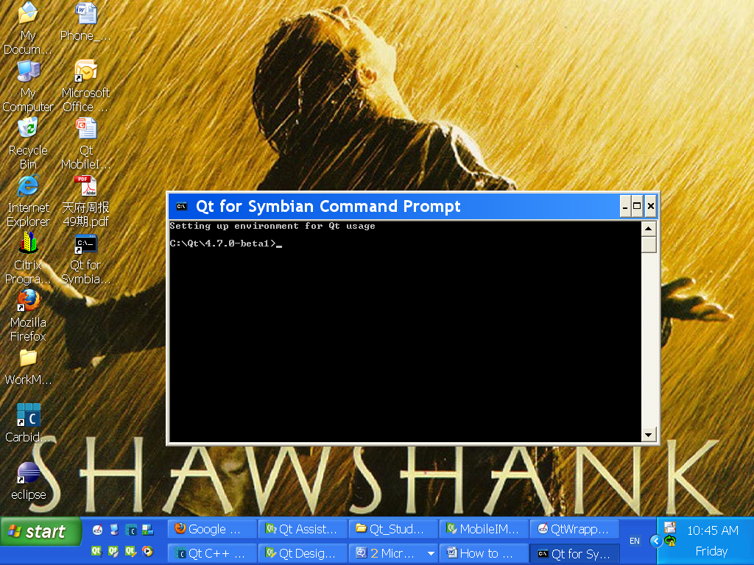

**2.**

Switch to your project directory firstly(**This is very important**), then input commands as below:

1)qmake

2)make reallyclean

3)make release-armv5

**3.**

1)Open your project directory manually, then copy the *-template.pkg and make a new *.pkg by yourself, change the name of it, e.g. JohnnyMobileIMServer_template.pkg ,the diagram as below:

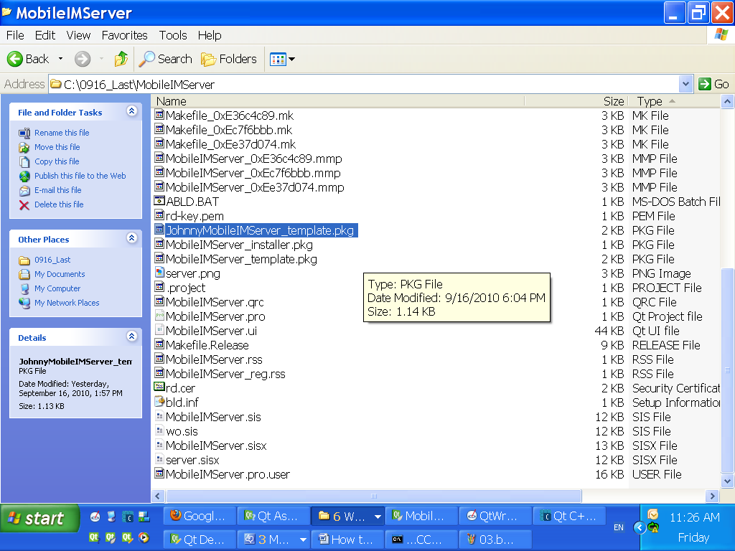

2)In the JohnnyMobileIMServer_template.pkg, change the MboileIMServer.exe path to the ……/armv5/urel. (The project name is MboileIMServer, so this MboileIMServer.exe is newly generated after compile)

The diagram as below:

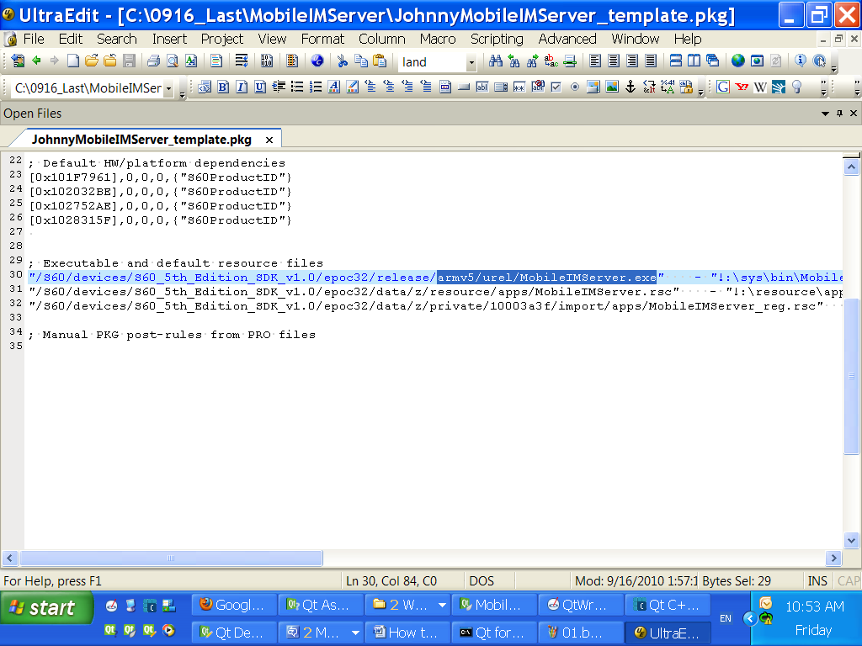

**4.**

Put rd.cer and rd-key.pem in your project directory, then make SIS with below commands:

1)makesis JohnnyMobileIMServer_template.pkg MobileIMServer.sis

2)signsis jo.sis MobileIMServer.sisx rd.cer rd-key.pem

Then in you project directory, you’ll find the SIS you made as below diagram:

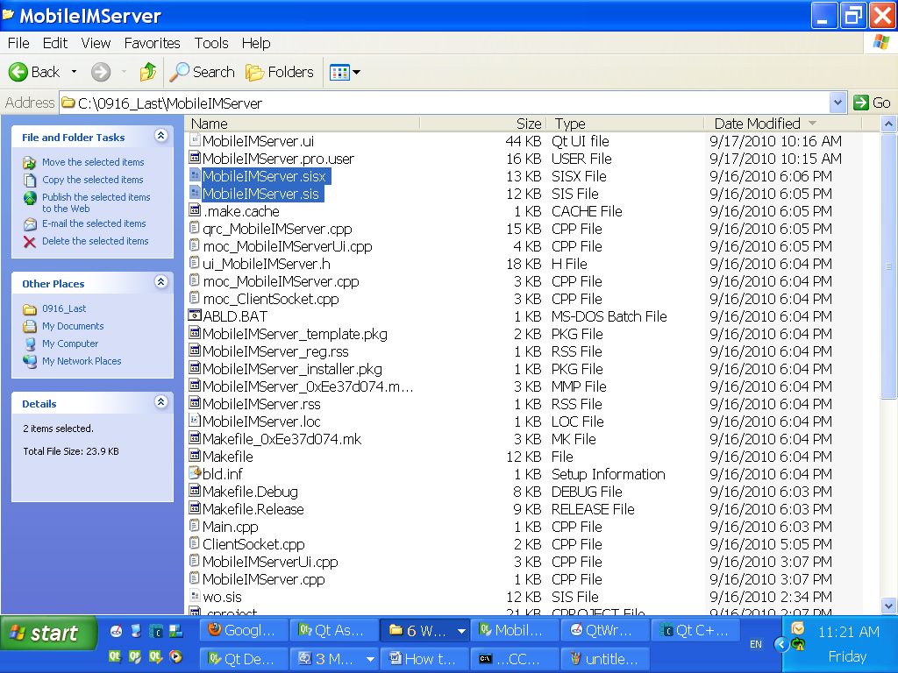

----Author: Johnny Liu

----Date: 09/17-2010